6 problems
12.05 and 12.39 is not in the book. Therefore I do not have the prolems
Problem 12.05 page 507-508
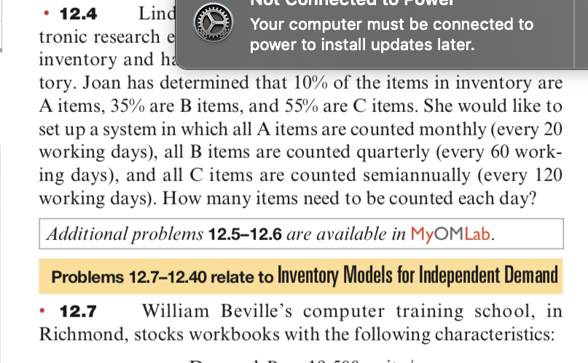

Problem 12.09 page 508
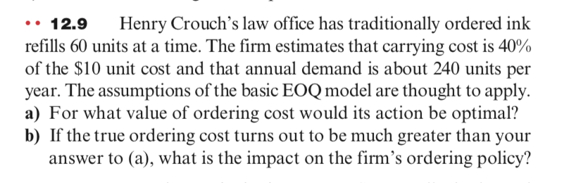

Problem 12.11 page 508
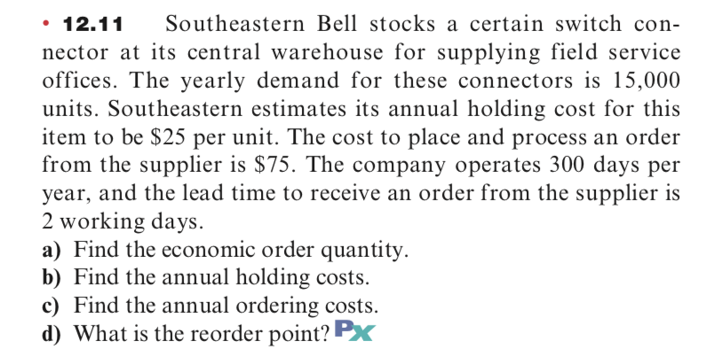

Problem 12.13 page 508
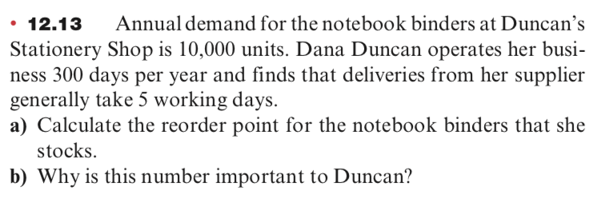

Problem 12.15 page 508
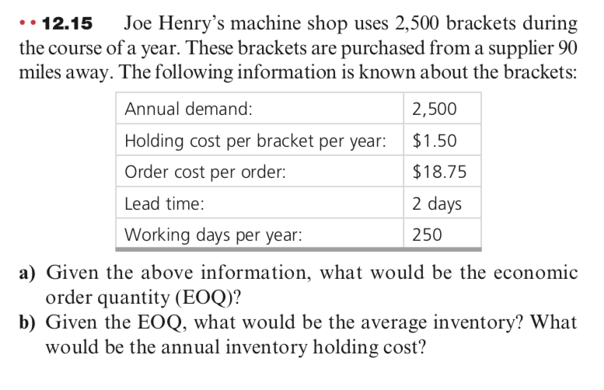
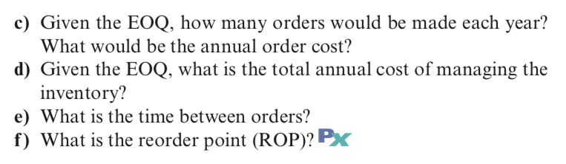

Problem 12.39 page 511
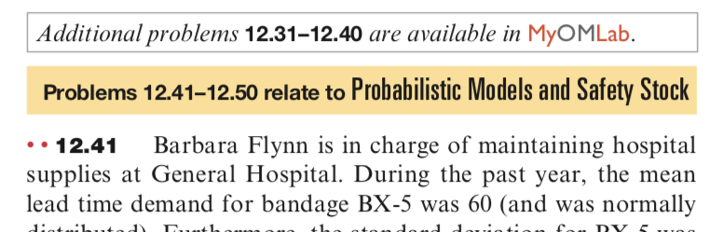

Problem 14.09 page 581
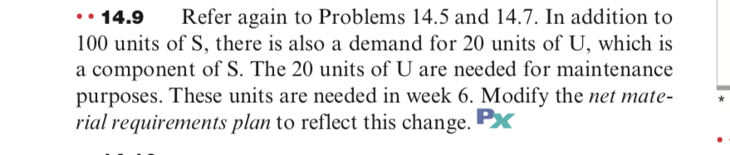

Problem 14.11 page 581
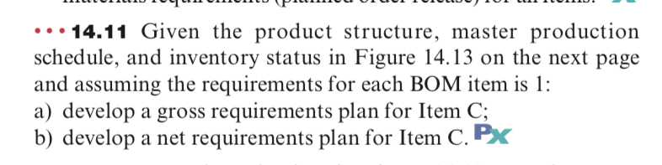

Problem 14.13 page 581
